**Project Design Phase-II**

**Technology Stack (Architecture & Stack)**

|  |  |
| --- | --- |
| Date | 31 October 2022 |
| Team ID | PNT2022TMID35420 |
| Project Name | Airline Data Analytics for Aviation Industry |
| Maximum Marks | 4 Marks |

**Technical Architecture:**

The Deliverable shall include the architectural diagram as below and the information as per the Table1 & Table2.

**Example:**

**Airline Data Analytics For Aviation Industry**

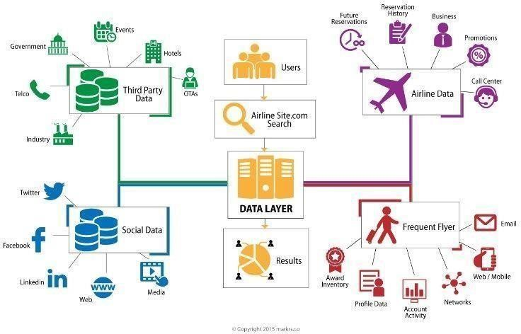

**Table-1: Components & Technologies:**

|  |  |  |  |  |  |  |
| --- | --- | --- | --- | --- | --- | --- |
| **S.No** | **Characteristics** | | **Description** | | **Technology** | |
| 1. | Open-Source  Frameworks | | List the open-source frameworks used | | Technology of open- source framework | |
| 2. | Security  Implementations | | List all the security/access controls implemented, use of firewalls. | | Example: SHA-256,  Encryption, IAM Controls,  OWASP | |
| **S.No** |  | **Components** |  | **Description** | | **Technology** |
| 1. |  | User Interface |  | How user interacts with application.  Example: Mobile App | | HTML, CSS, Java Script,  Excel |
| 2. | | Application Logic-1 | | Logic for a process in the  application | | IBM Watson STT service, Python |
| 3. | | Application Logic-2 | | Logic for a process in the  application | | IBM Watson Assistant |
| 4. | | Database | | Data Type, Configurations | | MySQL, NSQL |
| 5. | | Cloud Database | | Database service on cloud | | IBM DB2, IBM Cloudant |
| 6. | | File Storage | | File Storage requirements | | IBM Blocks Storage or other storage service or  Local File system |
| 7. | | External API-1 | | Purpose of External API used in the application | | IBM Weather API |
| 8. | | External API-1 | | Purpose of External API used in the application | | Aadhar API |
| 9. | | Infrastructure (Server/Cloud) | | Application Deployment on Local System/Cloud  Local Server  Configuration: Cloud  Server Configuration | | Local, Cloud Foundry |

**Table-2: Application Characteristics:**

|  |  |  |  |
| --- | --- | --- | --- |
| 3. | Scalable  Architecture | Justify the scalability of architecture | Cognos Used |
| 4. | Availability | Justify the availability of application (e.g: use of load balancers, distributed servers) | AWS Used |
| 5. | Performance | Design consideration for the performance of the application (number of requests per second, use of Cache, use of CDN’s) | Dashboard,Reports,Stories |